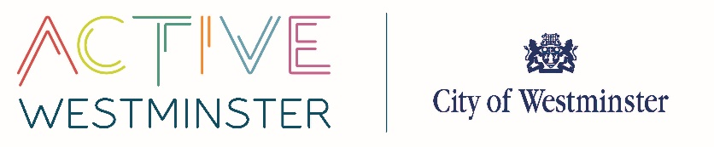
INDEMNITY FORM
WESTMINSTER CITY COUNCIL
CITY HALL
64 VICTORIA STREET
LONDON
SW1E 6QP

Date: _____/_____/_____

In consideration of Westminster City Council (“Council”) authorising and facilitating the;

- organisation, management and running of ‘Play Street’ sessions, in accordance with the Council’s Active Streets Programme Play’, facilitated via a Temporary Traffic Regulation Order (TTRO) under section 29A, Road Traffic Regulation Act 1984 which will take place on;

Date(s) of sessions _____________________________________________

between the hours of _________ and _________

at [address]: _____________________________________________
- I, the lead organiser of the ‘Play Street’ sessions, hereby agree to indemnify and hold harmless the Council against all liabilities, costs, expenses, damages and losses (including but not limited to any direct, indirect or consequential losses, loss of profit, loss of reputation and all interest, penalties and legal costs (calculated on a full indemnity basis) and all other reasonable professional costs and expenses) suffered or incurred by or arising out of or in connection with the ‘Play Street’ sessions.

Signed: _____________________________________________________

Printed Name: _____________________________________________________

Address: _____________________________________________________

_____________________________________________________

Telephone: _____________________________________________________

This indemnity form is to be signed and must be returned to Sport, Leisure and Active Communities (SL&AC), The Pavilion, Paddington Recreation Ground, Randolph Avenue, Maida Vale, W9 1PD or via email to active@westminster.gov.uk prior to any ‘Play Street’ sessions taking place.

