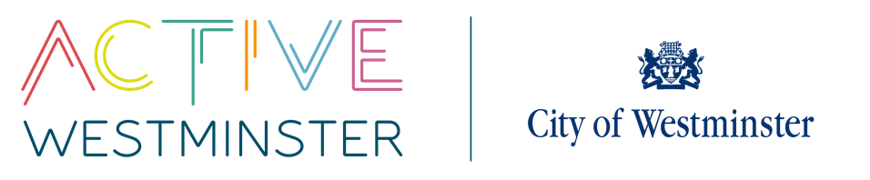
WESTMINSTER SCHOOLS COMPETITIONS

SECONDARY CROSS COUNTRY COMPETITION

VENUE: The Hub Regents Park MEMBERS/TEAM: 24
DATE: 3rd October 2024
TIME: 1:00pm - 3.00pm
YEAR GROUP: Year 7, 8, 9 and 10
----------------------------------------------------------------------------------------------------------------------------------------------------------------------------------------------------------
DESCRIPTION
There will be four age groups throughout the day; year 7/8, year 9/10. Each age group will be broken down further into boys and girls races.
The distances that each year group will cover are:
- 1:30 – Year 7,8 - 3km
- 2:10 – Year 9,10 – 4km

There will be individual winners for each race who will receive medals.
Each school will also run as a team with the top four runners scoring; four runners must complete the course in order to register points for the team event.
Athletes will also have the chance to represent their school and Westminster at the London Schools Athletics Cross Country Championships and London Youth Games.

