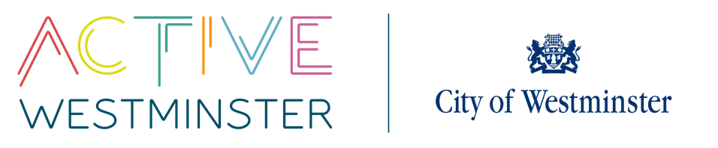
WESTMINSTER SCHOOLS COMPETITIONS

Competition | Multi-Skills | On-the-day Contact
Date | Year 4 – 11th June 2025  Year 3 – 18th June 2025  Year 2 – 25th June 2025  Year 1 – 2nd July 2025 | Time | AM session – 10:00am – 12:15pm  PM session – 12:45pm – 3:00pm  Please state whether you have a preference for the AM or PM sessions. We cannot guarantee your request
Venue | Paddington Recreation Ground, Maida Vale W9 1PD | Arrival | Please arrive 15 minutes before the competition is due to start
Lunch Information | Schools are welcome to arrive early/stay late to eat their lunch in the Park. Please be aware that there are certain areas that are off limits and schools need to be respectful of this. Also, please note that schools are not able to eat packed lunches in the cafe.
Festival Format | There will be a number of stations each linked to a skill or game. Schools will rotate around the stations spending 10 minutes at each.
Team Information | Teachers may bring their whole class to this event. Schools may enter more than one class, if this is the case please state the number of classes you wish to bring when you fill in the entry form.
Teacher expectations | Teachers are expected to take an active role at the festivals
PE Kits | All children should wear their PE kits to make them easily identifiable. Please bring warm clothing as the festival is outside and all children should be wearing appropriate footwear – preferably trainers.
First Aid | Schools should provide their own first aid. Whilst there will be qualified first aiders on site, this is not their primary function and first aid can be administered more swiftly if schools bring their own kits.
Equipment | All equipment is provided by WSU
Photography | There will be a WSU photographer present at this event. By entering the event you are allowing permission to photograph your students. If you have a student that is not able to be photographed, please make us aware on the day.
Contact | If you have any questions or queries please do not hesitate to contact: Angela Emanuel - 07940 021 907  aemanuel@westminster.gov.uk

