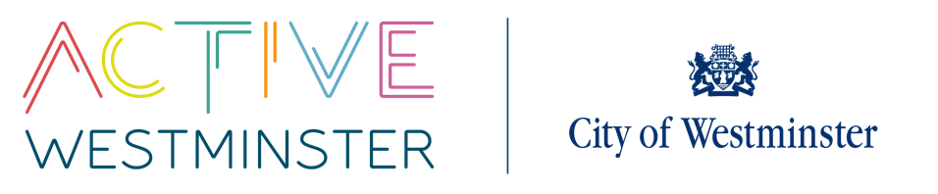
WESTMINSTER SCHOOLS COMPETITIONS

CROSS COUNTRY COMPETITION

VENUE: The Hub Regents Park MEMBERS/TEAM: 24
DATE: 2nd October 2025
TIME: 1:00pm – 3.00pm
YEAR GROUP: Year 7,8,9 &10/11
----------------------------------------------------------------------------------------------------------------------------------------------------------------------------------------------------------
DESCRIPTION
There will be four age groups throughout the day; year 7, 8, 9 & 10/11. Boys and girls from each year group will run together.
The distances that each year group will cover are:
- 1:15 Year 7 – 3km
- 1:40 Year 8/9 - 3km
- 2:00 Year 10/11 – 4km

Each school may enter 6 runners per race; a total of 24 runners. There will be individual winners for each race who will receive medals.
Each school will also run as a team with the top four runners scoring; four runners must complete the course in order to register points for the team event.

Follow on Event
There will be a follow in event for London Youth Game in November. Athletes will be selected from this event.

