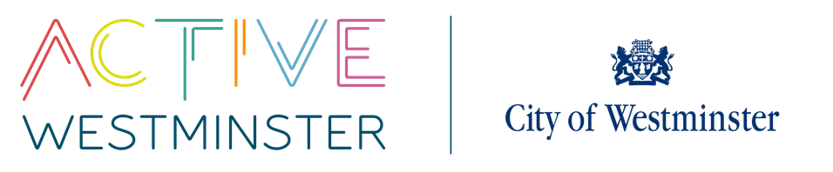
WESTMINSTER SCHOOLS COMPETITIONS

SECONDARY NETBALL TOURNAMENT
TEAMS: 12
VENUE: Paddington Rec

DATE: Year 9 - 17th November 2025
Year 8 – 20th January 2026
Year 7 – 24th February 2026
TIME: 10-2pm

YEAR GROUP: Year 7,8 & 9
----------------------------------------------------------------------------------------------------------------------------------------------------------------------------------------------------------
DESCRIPTION
There should be 7 players on court at all times filling the positions of GK, GD, WD, C, WA, GA and GS. Each squad should have a maximum of 16 players (only 16 medals will be provided for the winning team).
In cases where teams are made of mixed year groups, teams will play in the oldest age category.
There is a Level 3 county finals School Games competition for year 7 players. The winner of the year 7 league will be put forward to represent Westminster.
Active Westminster will provide size 5 balls. Schools may want to take their own balls to fixtures for warm ups.

Competition Rules

