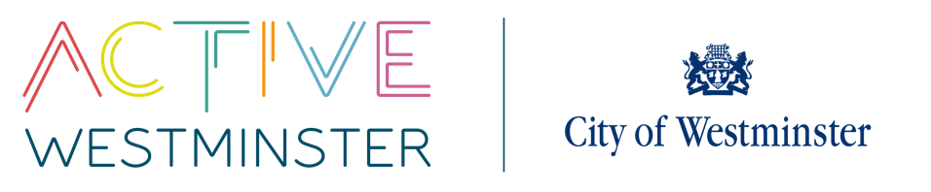
WESTMINSTER SCHOOLS COMPETITIONS

PRIMARY BEES NETBALL
Information
Competition | Year 5/6 Bees Netball Competition | On-the-day Contact
Date | Paddington Rec – 18th November 2025 | Venue | Paddington Rec, Maida Vale, W9 1PD  Queen Mother SC, 223 Vauxhall Bridge Rd, SW1V 1EL
Time | 10:00am – 14:00pm | Arrival | Please arrive 15 minutes before the competition is due to start
Entry Information | There will be one competition in the north of the city (Paddington Recreation Ground) and one in the south of the city (Queen Mother). Each competition will cater for eight teams – 16 teams across each year group. Places will be allocated on a first come, first served basis. If the first preference venue is filled, schools will automatically be moved to the other competition.
Competition Format | These competitions will be using a Hi5 competition format. Rules, including the rotations can be found on the England Netball website: http://www.englandnetball.co.uk/my-game/High_5/high-5-downloads. A hard copy is included later in the guide.  The competition itself will be a round-robin format with several pools as necessary. Quarter/semi/finals as needed.
Team Information | There should be 5 players on the pitch and squads should have a maximum of 9 players. Players should be in years 5 and/or 6  Due to rules at the Level 3 School Games competition, there should be no more than three boys on your squad. But a squad can consist of all girls. Teams with more than three boys will not be allowed to go through to the knock out stages of the competition.
Follow-On Opportunities | The winner of the North competition and the South competition will need to meet to play off to decide the overall borough winner. The borough winner will then go forward to represent Westminster at the Level 3 School Games event in the spring.

PE Kits | All children should wear their school PE kit for this competition. Schools should bring at least one set of bibs to the competition.
Equipment | Match balls will be provided by PALS team, but schools may wish to bring a few balls with them to warm up with. Schools should also bring with them at least one set of Netball bibs.
First Aid | Schools should provide their own first aid. Whilst there will be qualified first aiders on site, this is not their primary function and first aid can be administered more swiftly if schools bring their own kits
Photography | A photographer may be in attendance, please make sure that all your team members have photographic consent. If you have a child that is not able to be photographed please let the PALS team know on arrival.
Contact | If you have any questions or queries please do not hesitate to contact Angela Emanuel-Carr.  Tel: 020 7641 5879  Mob: 07940 021 907  Email: aemanuel@westminster.gov.uk

