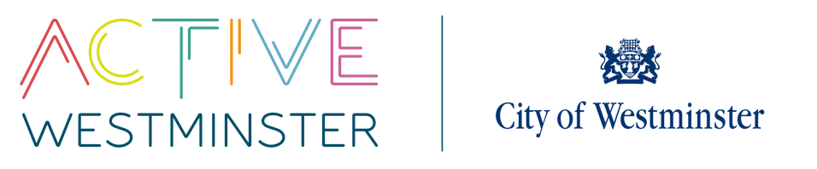
WESTMINSTER SCHOOLS COMPETITIONS

PRIMARY CROSS COUNTRY COMPETITION

VENUE: The Hub Regents Park MEMBERS/TEAM: 24
DATE: 2nd October 2025
TIME: 10.00am – 12.00pm
YEAR GROUP: Year 3, 4, 5 and 6
----------------------------------------------------------------------------------------------------------------------------------------------------------------------------------------------------------
DESCRIPTION
There will be four age groups throughout the day; year 3/4, year 5/6. Each age group will be broken down further into boys and girls races.
The distances that each year group will cover are:
- 10:40 Year 3/4 – 1km Girls
- 10:50 Year 3/4 – 1km Boys
- 11:15 Year 5/6 – 1.5km Girls
- 11:40 Year 5/6 – 1.5km Boys

Each school may enter 6 runners per race; a total of 24 runners. All year 3/4 will run together with the same for year 5/6 athletes.
Each school will also run as a team with the top four runners scoring; four runners must complete the course in order to register points for the team event.
There will be individual winners for each race who will receive medals.

