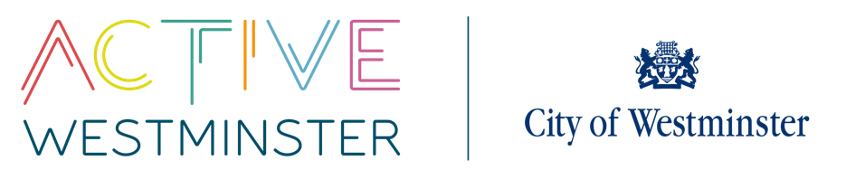
WESTMINSTER SCHOOLS COMPETITIONS

KWIK CRICKET
 | Information
Competition | Year 7/8 Boys and Girls 1-Day Cricket
On-the-day Contact | Carjez Bryan
Date | 18th June 2026
Venue | Regent’s park, The Hub, Outer Circle, London, NW1 4RU
Time | 10am – 2pm
Competition Format | Format will depend on entries and will be sent out prior to the competition.  This will be soft-ball cricket (Kwik Cricket) - bowling will be over-arm.
Team Information | Teams are separate gender.  A team should consist of 8 players at any one time with 10 players in a squad.
PE Kits | Children should be wear their normal PE kits and bring warm clothing as we will be outside all day.
Equipment | Schools should bring one Kwik Cricket set with them. Please ensure that all parts of the kits are marked with the school’s name so that it can be identified and returned.  Children should bring lunch and plenty of water.  We also suggest that schools bring sun-block.
Umpires | Schools will be asked to umpire the games themselves
First Aid | Schools will be required to provide their own first aid so please make sure that you bring a kit with you.
Photography | A photographer will be in attendance at some point, please make sure that all your team members have photographic consent.
Contact | If you have any questions or queries please do not hesitate to contact Angela Emanuel-Carr  Tel: 020 7641 5879  Email: aemanuel@westminster.gov.uk

