- 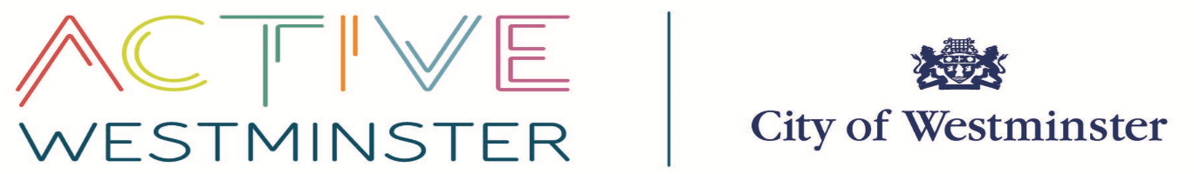

Westminster Secondary Schools PE & School Sport Offer 2026-27

The Sports, Leisure and Active Communities team is uniquely placed to offer a comprehensive service to schools at the best possible value. We can broker quality services from partners in education, sport and physical activity to help develop and deliver a full PE and school sport offer to your school. The team has the support of a full time School Games Organiser (Angela Emanuel-Carr) and a Relationship Manager for Sport (Jonathan Hearn) and unlike commercial providers; there is no premium to cover the cost of overheads or profit margins.

There are two membership options: (Membership Fee Price Freeze this coming school year).

- Full PESS Membership (access to the whole Westminster PE and School Sport package)
  - Single-sex Schools £350
  - Mixed Schools £700
- Half PESS Membership (access to up to 5 one-day competitions. Please note entry to the leagues is not included)
  - £250

PESS membership gives you access to the following services:

Competition:
    - Annual competition calendar: 21 competition days, covering 11 different sports and including some School Games Level 2 competitions.
  - Fixtures, venues and officials organised for three female leagues (Netball, Football and Basketball) and two male leagues (Football and Basketball).

Leadership Academy:
    - The Leadership Academy runs throughout the Academic year. Schools will be offered one sport specific course (NGB or sports company lead course) and one follow-up leadership session. Schools will also be assigned three School Games Level 2 competitions for their Sports Leaders to attend and support. There might also be opportunities for students to support at School Games Level 3 competitions.

Network Meetings:
  - Three half day meetings (once a term) which includes updates from our partners (Youth Sports Trust & London Youth Games), Active Westminster (formerly SL&AC) competition review, CPD sessions and opportunity to network with other schools and leisure providers. A Review Day takes place in June and includes evaluating the year gone and planning for the next academic year.

School Games Mark Support:
  - Individual visits made by the School Games Organiser to your school to help you understand the School Games criteria and to identify which level (Bronze, Silver, Gold or platinum) your school should apply for.

Active Westminster Website
- Providing downloadable information about competitions, events and important updates from our partners.

Support from an experienced PE Advisor (Jan Hickman)
- Jan is able to discuss curriculum development in PE particularly based on Health and Well-Being. If you are interested in working with Jan please contact Jan@hickmanconsulting.co.uk
Alongside these listed services, the ActiveWestminster Partnership will bring members additional benefits and programmes of activity to schools, for example:

- Champions of the future: athletes that live or go to school in Westminster and represent their sport at a regional, district or national level have the opportunity to apply for funding.
- Club Links: Our partnership with Middlesex Cricket Club (MCC) and Lords gives all Westminster schools an exciting package, which includes cricket provision, training and match tickets all for no cost. Our dedicated Relationship Officer – Sport (Ian Bannister) can support schools to create links with local sport clubs and organisations that have been awarded the ActiveWestminster accreditation Mark for achieving a set of minimum standards.
- NGB Links: Our close relationship with a variety of National Governing Bodies (NGB’s) keeps you updated with their school offers and external club links
- Westminster Mile: Our partnership with the London Marathon Trust https://www.vitalitywestminstermile.co.uk/ enables us to offer over 300 free school places for the annual Westminster Mile. Please contact Ian Bannister ibannister@westminster.gov.uk for more information.

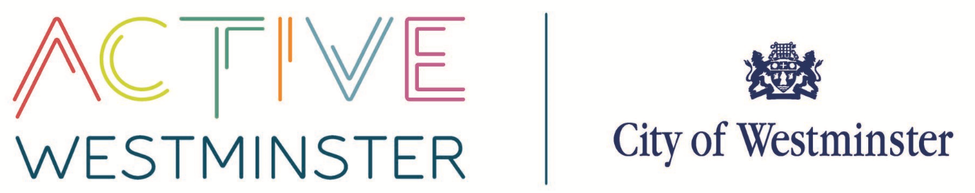
Membership Application Form 2026-27

Please complete the below details and email or post to aemanuel@westminster.gov.uk or Angela Emanuel, The Pavilion, Paddington Recreation Ground, Randolph Avenue, Maida Vale, London, W9 1PD .

There are two Membership options:

- Full Membership (access to all the Westminster PE & School Sport offer)
  - Single-sex Schools £350
  - Mixed Schools £700
- Half Membership (access to up to 5 one-day competitions. Please note entry to the leagues is not included)
  - £250

School Name
PE Coordinator Name
Email address
Phone & mobile no. | Tel:  Mob:
Membership selection  (please tick) | Full Membership Half Membership
School payment details  (journal transfer) | Cost Centre:  Account Code:
Head Teacher/approver signature | ………………………………………………
If you have any specific requirements please detail here or speak direct to the team

DEADLINE: PLEASE RETURN THIS FORM BY Friday 25th September 2026

Sport, Leisure and Active Communities (formerly PALS) – key contacts for PE and School Sport
Please contact the team if you have any questions or would like to arrange a meeting to discuss anything more and consider your specific needs.

Angela Emanuel-Carr
Relationship Officer – PE & School Sport/School Games Organiser (Competitions, School Games level 2 & 3)
07940 021907/ aemanuel@Westminster.gov.uk

Westminster programs and partners:
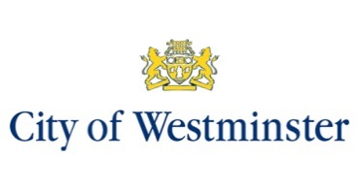
Westminster City Council provides community, leisure, tourism, transport, environment and business information and services. The Sport Leisure & Active Communities (SL&AC) teams (previously known as Westminster Sports Unit) sits within the council’s broader Communities team within Environment & Communities. Our team also manages the leisure contract across the city. (Sports and Leisure Management operate our leisure centre’s under contract and are branded as Everyone Active).
Westminster Sports Unit including our current incarnation SL & AC has existed for around 34 years providing school and community programmes for young people and adults. Based at Paddington Recreation Ground the Sports Leisure Active Communities team are focused on making people across Westminster more active, healthier and happier in their lives through physical activity and sports participation.

Meet the team:
Richie Gibson: Director of Culture and Place Shaping
Coreen Brown: Head of Sport, Leisure & Wellbeing
Jonathan Hearn: Relationship Manager - Sport
(School Sport, London Youth Games, Sports Club Engagement & Development, Sports Volunteering)
Angela Emanuel: Relationship Officer – Sport/School Games Organiser
(School Games and Competitions)
Ian Bannister: Relationship Officer – Sport
(Clubs, ActiveWestminster Mark, Champions of the future, Westminster Mile)
Max Goodchild: Relationship Manager – Physical Activity
(Physical Activity, wellbeing and target groups)
Andrew Leckie: Relationship Manager – Physical Activity
(Physical Activity, wellbeing and target groups)
Richard Spencer: Relationship Officer – Physical Activity
(Community Sport, Training, CPD and NSC)
Farran Leach: Relationship Officer – Sport & Physical Activity
Sonia Martinez-Roura – Relationship Officer – Digital Marketing

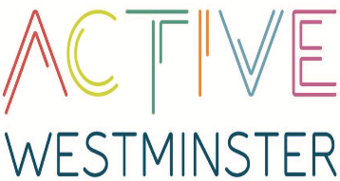
ActiveWestminster is our partnerships brand that encompasses all PE, sport and physical activity programmes and partners in Westminster. The partnership brings together around 300 professional sports clubs and voluntary, private and community-based stakeholders to improve the opportunities to everyone that lives, studies and works in Westminster. You will also notice this branding used on our new web site www.activewestminster.org and other promotional materials that are sent out to schools.

The ActiveWestminster Mark is a two-year minimum standards accreditation mark which shows Westminster residents that independent coaches, clubs or organisations can:
* Meet a range of minimum standards set by the ActiveWestminster partnership including health and safety, safeguarding, appropriate coaching qualifications and insurance.

London Sport is our regional County sport and physical activity body funded by Sport England. They have a dedicated PE and School Sport team responsible for working closely with local authorities and sport units to support schools to utilise the Primary PE premium funding.



The Tri-borough Healthy Schools Partnership was launched in 2012, with the aim to support schools to focus on health and wellbeing. We are working closely with the Healthy Schools Team to ensure our programmes are aligned and offer added value to schools. Schools can apply for the healthy schools partnerships bronze, silver and gold awards.
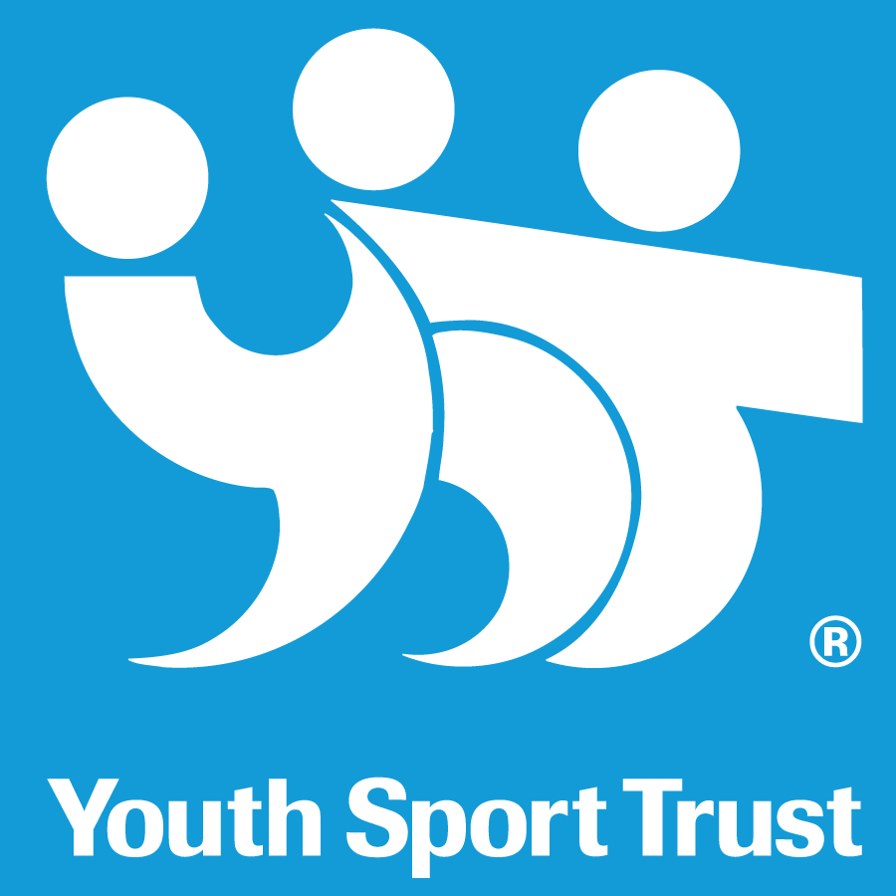
The Youth Sport Trust is a charity which focuses on quality PE and School Sport. Their mission is to change young people’s lives through sport. They are commissioned by Sport England to be the strategic agent for the School Games, offering support and advise to the Levels 1-3 delivery partners.

London Youth Games (LYG) is the largest youth sports festival within Europe. It takes place over 9 months and includes school and community competitions across 30 different sports. London Youth Games also organise the School Games Finals.

Established by a former Primary schools Head Teacher, the Daily Mile removes barriers to physical activity for teachers and pupils. Pupils can run, jog or walk a set route around the school for 15 minutes every day.

The Youth Sport Trust is the UK's leading charity improving every young person's education and development through sport and play. Working together, we empower young people to achieve their own personal best and equip educators to change lives.

Our purpose is to promote and maintain high standards and safe practice in all aspects and at all levels of physical education, school sport and physical activity influencing developments at national and local levels that will impact on pupils’ physical health and emotional well-being.
We provide quality assured services and resources, and valuable professional support for our members and the physical education, school sport and physical activity sector.

